**What is the Air Quality Index?**

• Index for **reporting air quality**

• **Color is key** for communication

• Ranges from **0 to 500** (no units)

• Provides indicator of the quality of the air and its health effects

• The AQI measures five criteria air pollutants :

* **Particulate Matter PM2.5**
* Sulfur dioxide S2O
* Carbon monoxide CO
* Nitrogen dioxide N20
* Ozone O3

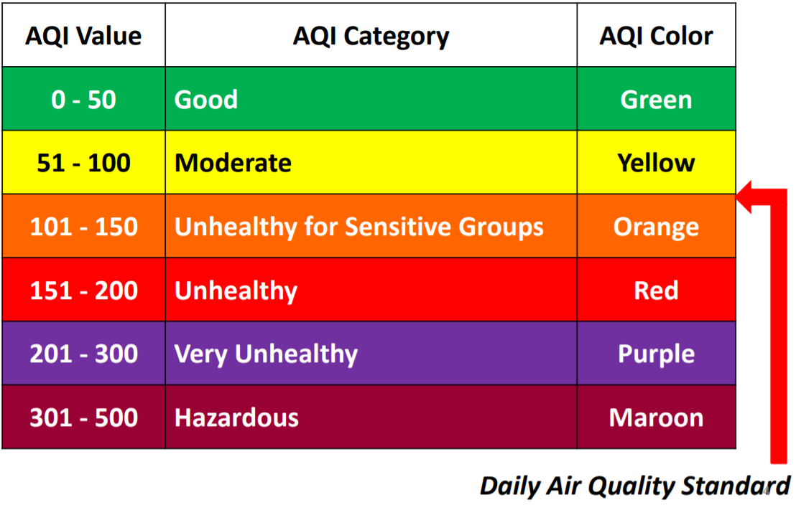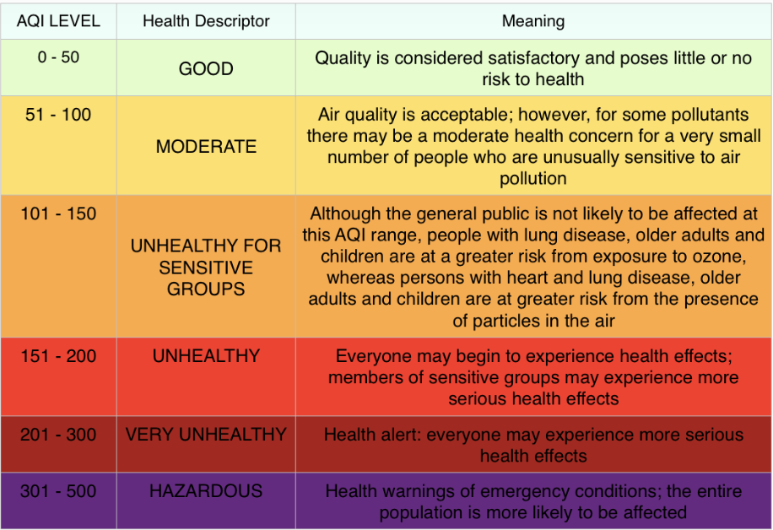

**PM2.5 – AQI:**

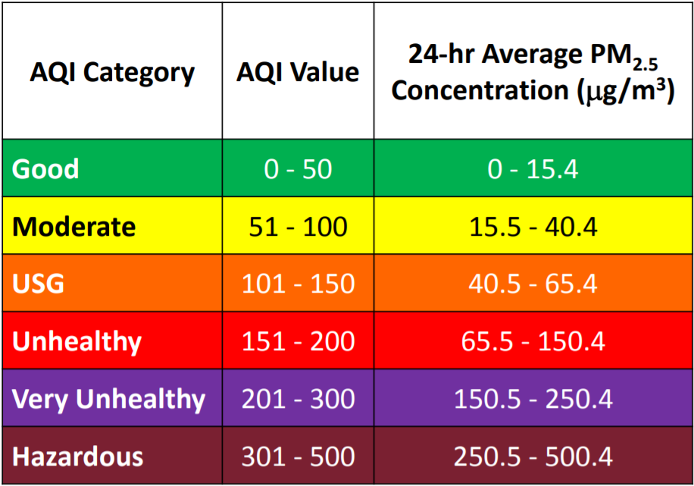

**PM10 – AQI:**

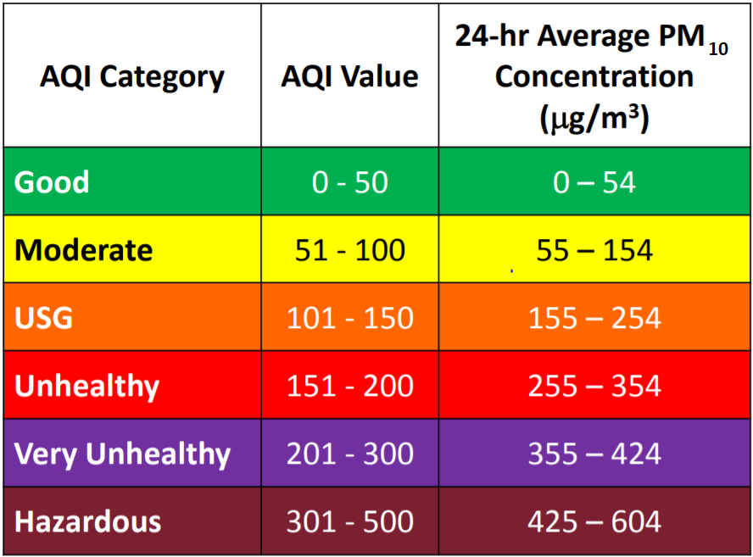

**Other Pollutants to AQI:**

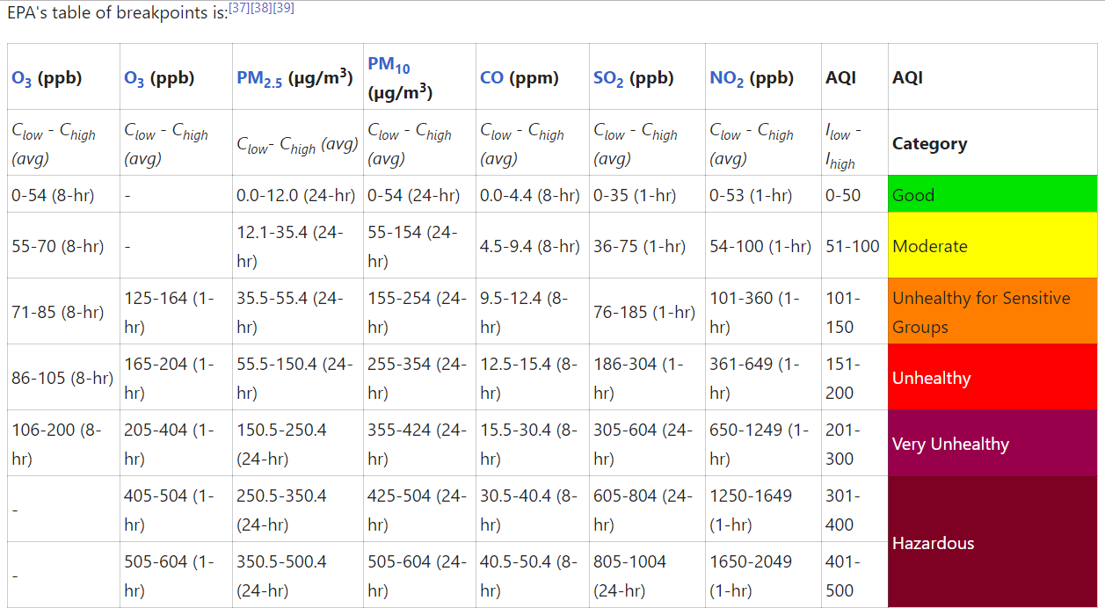

**AQI Calculation:**

